42.6: a) 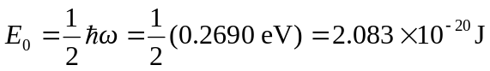
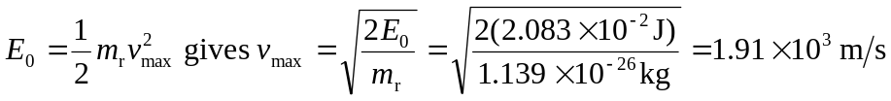
b) According the Eq. 42.7 the spacing between adjacent vibrational energy levels is twice the ground state energy:
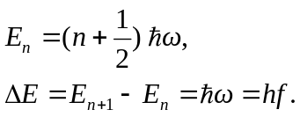
Thus, using the 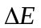 specified in Example 42.3, it follows that its vibrational period is
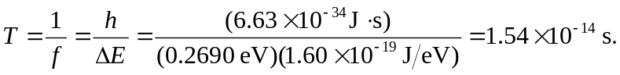
c) The vibrational period is shorter than the rotational period.

